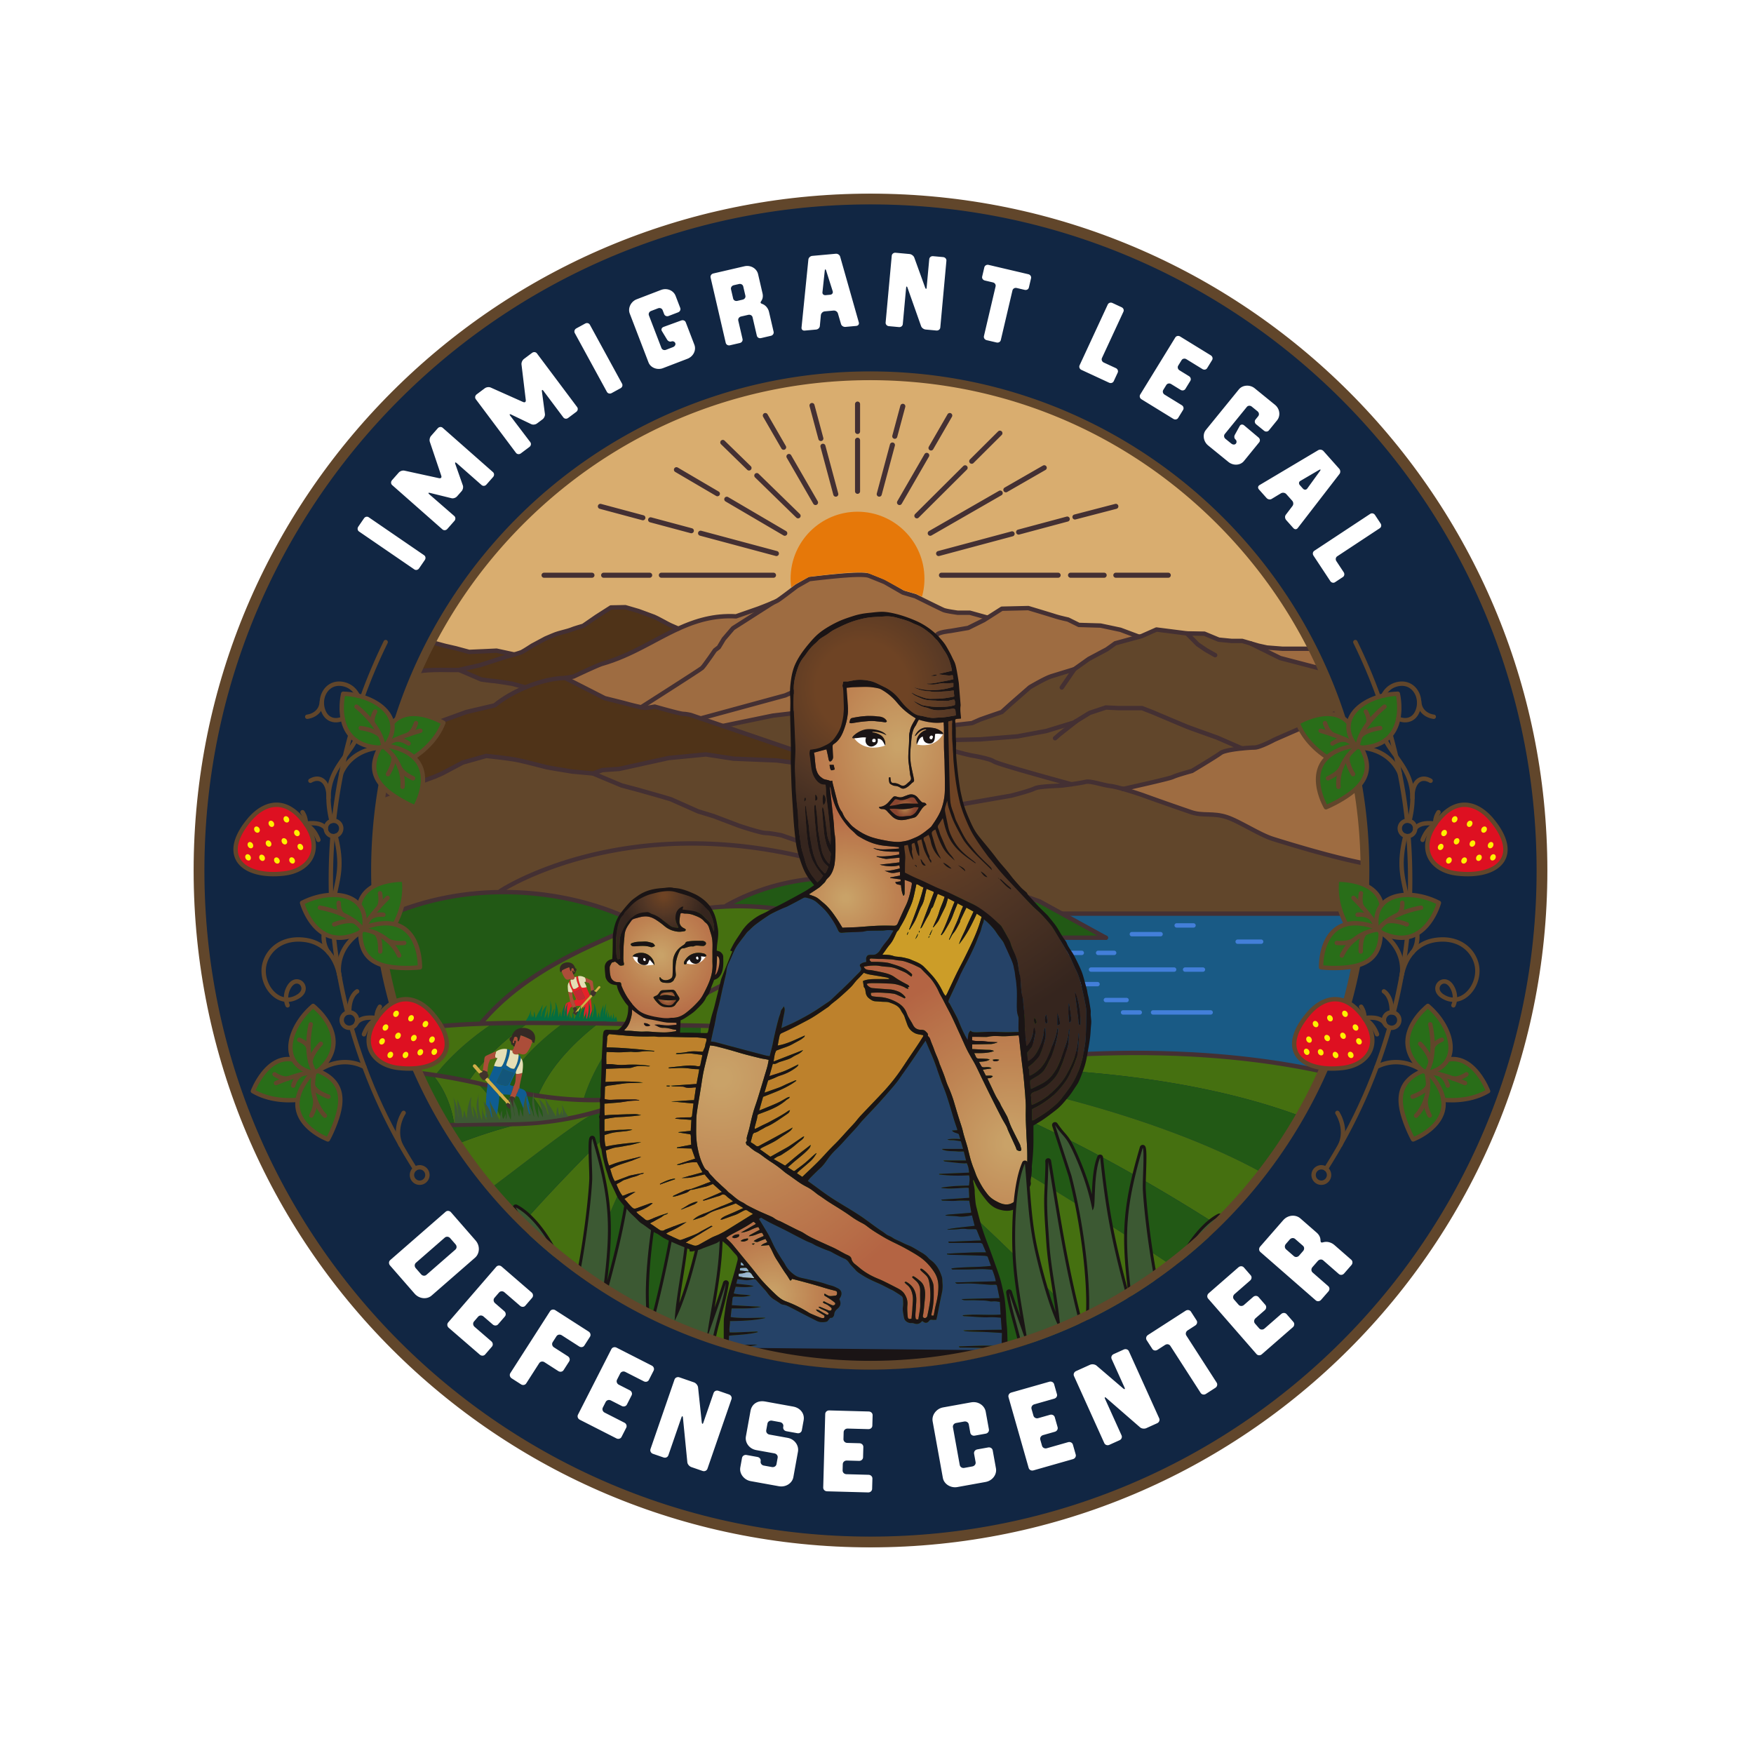

Development & Communications Coordinator
Immigrant Legal Defense Center (ILDC)
Location: Santa Barbara, CA (In-Person)
Compensation: $25 – $30/hour (Part-Time w/Full-Time Step up Opportunity)
Reports to: Operations Associate

About ILDC
The Immigrant Legal Defense Center (ILDC) is committed to ensuring equal access to justice and due process for low-income immigrants facing removal proceedings. We believe that no one should face immigration court alone. Through free legal representation, trauma-informed services, and community-based advocacy, ILDC works to address systemic inequities in the immigration system across the Central Coast.

Position Overview
The Development & Communications Coordinator plays a critical role in advancing ILDC’s mission by supporting fundraising operations and strengthening donor and community engagement. This position is responsible for managing donation processing, maintaining donor records, coordinating fundraising communications, and supporting development campaigns and events.
This position will begin as part-time, with the opportunity to transition to full-time employment after two months, contingent on strong performance and organizational needs.
This is an in-person role based in our Santa Barbara office. Limited remote work flexibility (up to two days per week) may be offered after the initial onboarding period and is subject to demonstrated performance and role requirements.
This is an ideal role for someone who is highly organized, detail-oriented, and passionate about immigrant justice, with an interest in nonprofit development and storytelling.

Key Responsibilities

Development Operations & Donor Management
- Process donations (online, checks, grants) and ensure accurate and timely entry into donor database
- Maintain and update donor records, ensuring data integrity and confidentiality
- Generate donation reports and assist with tracking fundraising progress and goals
- Coordinate donor acknowledgments and inventory, including thank-you letters, tax receipts and gifts
- Support grant tracking, reporting deadlines, and documentation

Fundraising & Communications
- Draft and coordinate donor communications, including newsletters, email campaigns, and impact updates
- Support development of fundraising materials, including appeals, reports, and presentations
- Assist in planning and executing fundraising events, donor gatherings, and community outreach efforts
- Manage and update website content and support social media efforts aligned with ILDC’s mission
- Help tell ILDC’s story by highlighting client impact, program outcomes, and advocacy work

Administrative & Cross-Team Support
- Collaborate with legal, advocacy, and mental health teams to gather program data and impact stories
- Support internal systems to improve efficiency in development and communications workflows
- Assist Executive Director with special projects related to fundraising and partnerships

Qualifications
- 1–3 years of experience in nonprofit development, fundraising, communications, or related field
- Strong organizational skills and attention to detail, especially in data management
- Excellent written and verbal communication skills
- Experience with donor databases
- Proficiency in Google Workspace; familiarity with email and social media marketing tools and graphic design platforms (e.g., Wix, Canva, Instagram, Facebook) a plus
- Ability to manage multiple projects and meet deadlines in a fast-paced environment
- Demonstrated commitment to immigrant rights, social justice, and equity

Preferred Qualifications
- Bilingual in English and Spanish
- Experience working in a nonprofit or community-based organization
- Familiarity with fundraising campaigns, donor stewardship, or grant support

What We Offer
A career at ILDC offers the opportunity to work with a team of professionals driven by a shared commitment to defending immigrants' rights and advancing due process. Our benefits include:
- Generous paid time off, plus 10 holidays and a two-week winter break
- Medical and dental benefits
- Retirement benefits
- Student Loan Repayment Assistance
- Generous parental and family leave
Note: Benefits eligibility will apply upon transition to full-time status.

Why Join ILDC?
- Be part of a mission-driven team advancing justice and due process for immigrant communities
- Work in a collaborative, trauma-informed environment
- Opportunity to grow within nonprofit development and advocacy work
- Engage directly in impactful, community-centered initiatives

How to Apply
Please submit a resume and brief cover letter outlining your interest in the role and alignment with ILDC’s mission to brenda@sbimmigrantdefense.org

